BÁO CÁO THỰC HÀNH LAB 2  
LẬP TRÌNH HƯỚNG ĐỐI TƯỢNG

## 5. Create Aims class

## 6. Create the DigitalVideoDisc class and its attributes

## 7. Create accessors and mutators for the class DigitalVideoDisc

## 8. Create Constructor method

## 9. Create the Cart class to work with DigitalVideoDisc

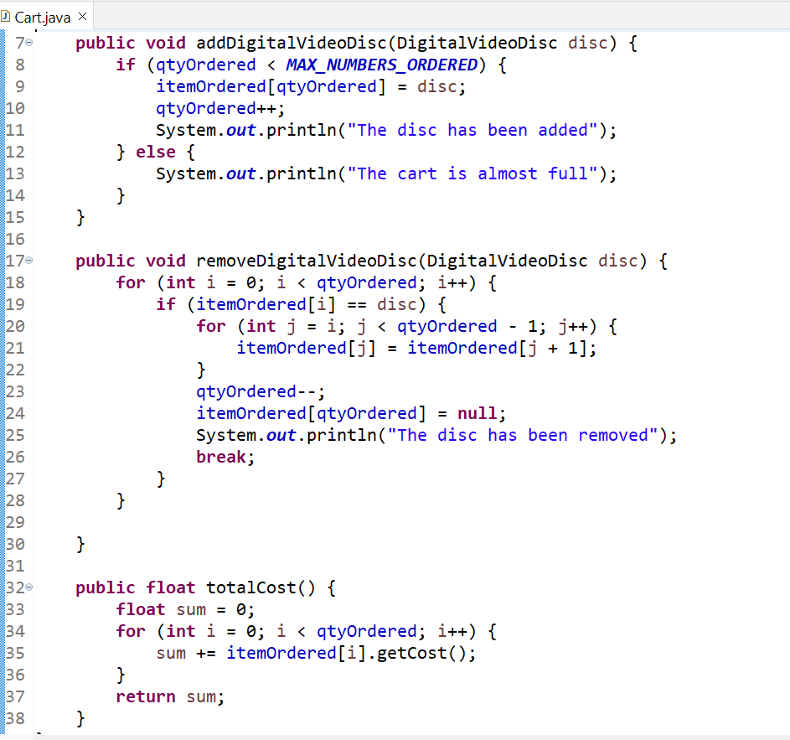

## 10.Create Carts of DigitalVideoDiscs

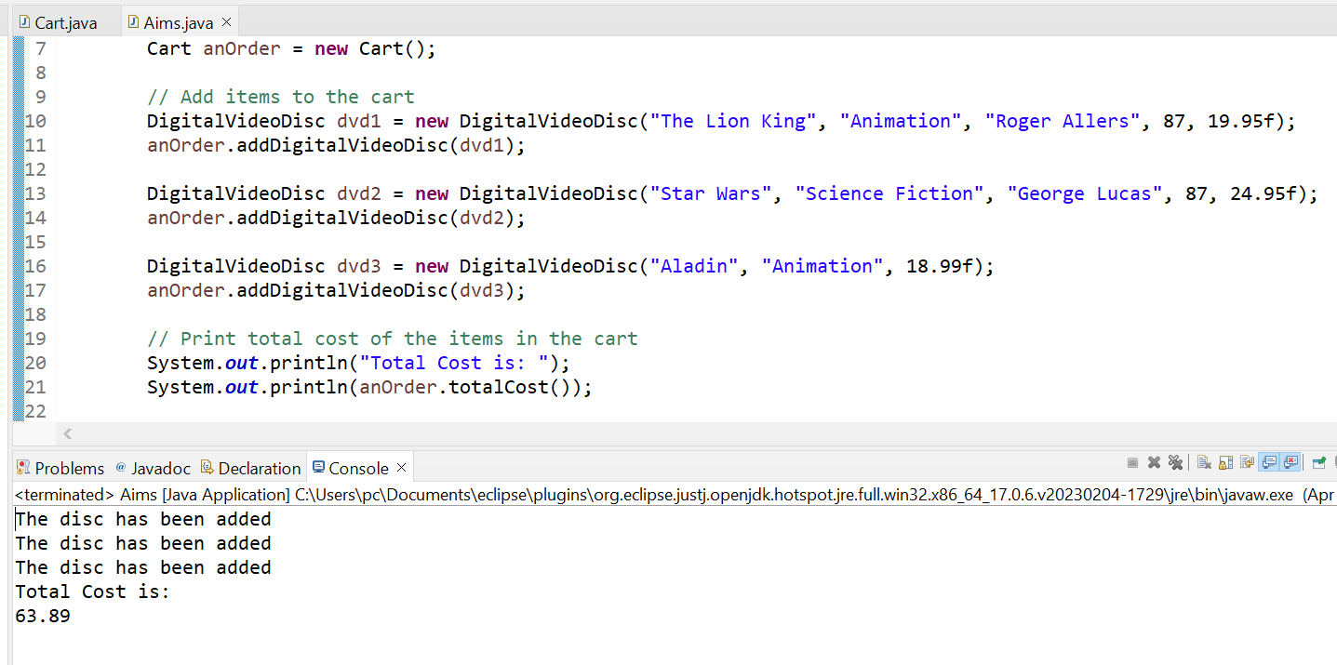

## 11.Removing items from the cart

